**TASK-02**

Area of Rectangle

**EXPLANATION:**

The program asks user to input the length of width of two rectangles. If user enters a character the program gives an error and then returns the user to the again asking the length or width. In the end, it calculates the areas of the two rectangles and tells weather the area is same or different.

**INPUT:**

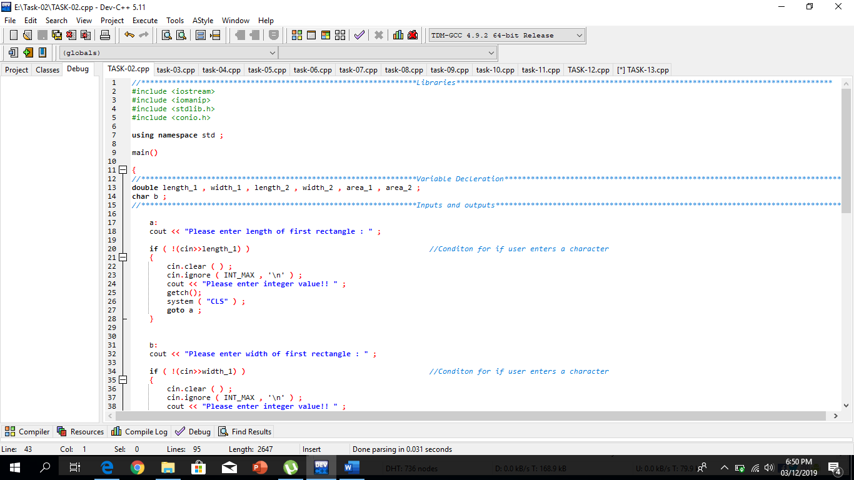

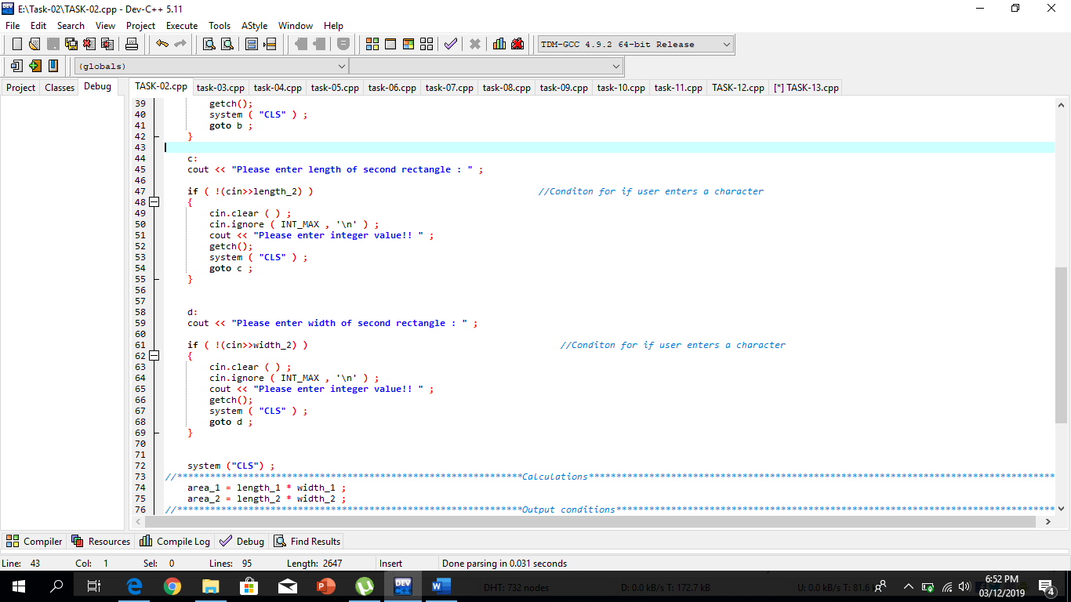

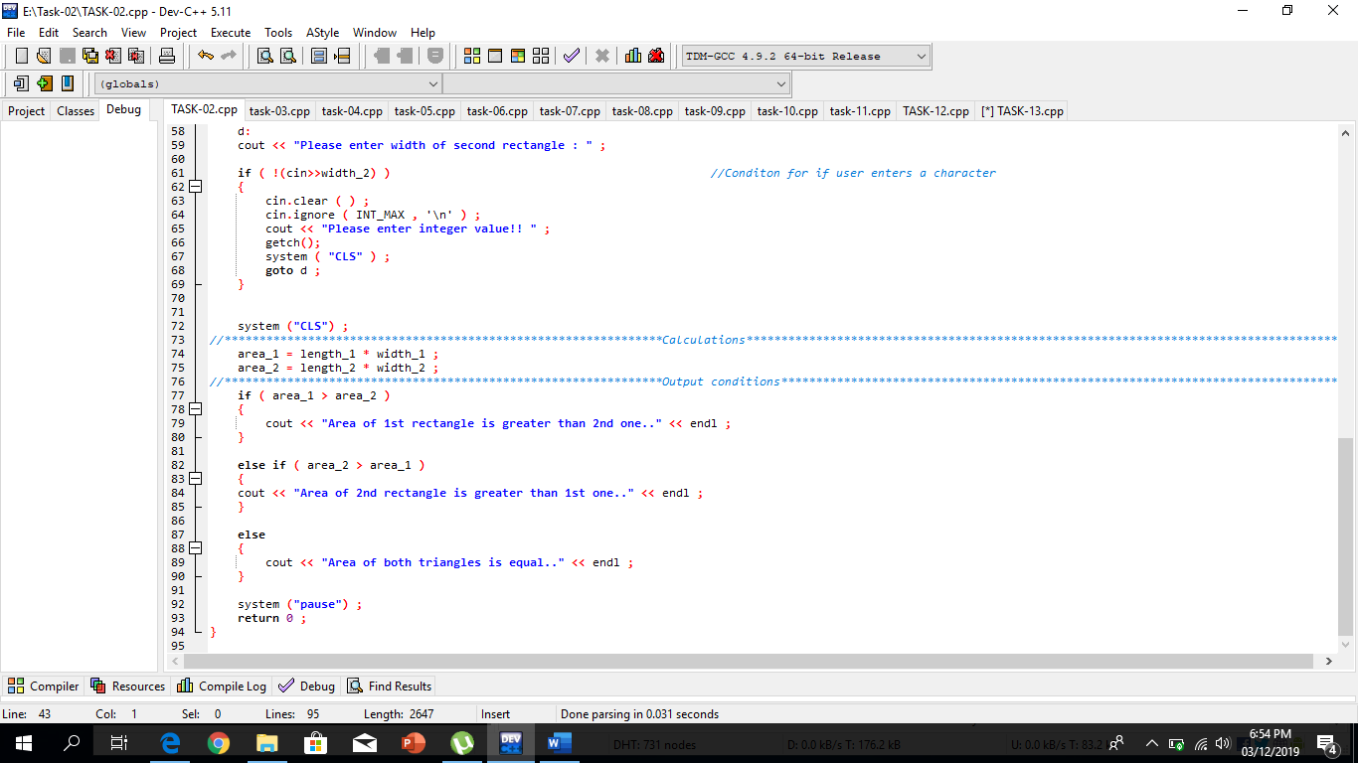

**OUTPUT:**

